Hill cipher is a polygraphic substitution cipher based on linear algebra. Invented by Lester S. Hill in 1929, it was the first polygraphic cipher in which it was practical (though barely) to operate on more than three symbols at once.
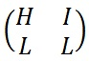

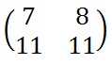

requires the user to have an elementary understanding of matrices. It also make use of Modulo Arithmetic. because of this, the cipher has a significantly more mathematical nature than some of the others.

Encryption:

To encrypt a message using the Hill Cipher we must first turn our keyword into a key matrix (a 2 x 2 matrix for working with digraphs, a 3 x 3 matrix for working with trigraphs, etc). We also turn the plaintext into digraphs (or trigraphs) and each of these into a column vector. We then perform matrix multiplication modulo the length of the alphabet (i.e. 26) on each vector. These vectors are then converted back into letters to produce the ciphertext.

the first step is to turn the keyword into a matrix.

If the keyword was longer than the 4 letters needed, we would only take the first 4 letters, and if it was shorter, we would fill it up with the alphabet in order

With the keyword in a matrix, we need to convert this into a key matrix. We do this by converting each letter into a number by its position in the alphabet (starting at 0). So, A = 0, B = 1, C= 2, D = 3, etc.

We now split the plaintext into digraphs, and write these as column vectors. That is, in the first column vector we write the first plaintext letter at the top, and the second letter at the bottom. Then we move to the next column vector, where the third plaintext letter goes at the top, and the fourth at the bottom. This continues for the whole plaintext.

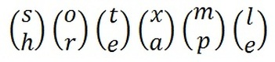

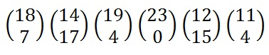
Now we must convert the plaintext column vectors in the same way that we converted the keyword into the key matrix. Each letter is replaced by its appropriate number.

Now we must perform some matrix multiplication. We multiply the key matrix by each column vector in turn. We shall go through the first of these in detail, then the rest shall be presented in less detail. We write the key matrix first, followed by the column vector.

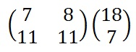

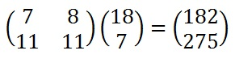

Next we have to take each of these numbers, in our resultant column vector, modulo 26 (remember that means divide by 26 and take the remainder).

Decryption
To decrypt a ciphertext encoded using the Hill Cipher, we must find the inverse matrix. Once we have the inverse matrix, the process is the same as encrypting.

to find the inverse of the key matrix, we perform the calculation below, where K is the key matrix, d is the determinant of the key matrix and adj(K) is the adjugate matrix of K.
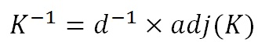

Determninant of k:
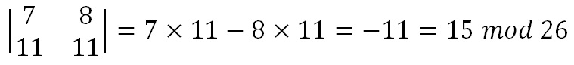
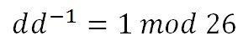
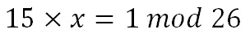
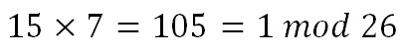
We now have to find the multiplicative inverse of the determinant working modulo 26. That is, the number between 1 and 25 that gives an answer of 1 when we multiply it by the determinant. So, in this case, we are looking for the number that we need to multiply 15 by to get an answer of 1 modulo 26. There are algorithms to calculate this, but it is often easiest to use trial and error to find the inverse.

Now find adjoint of matrix:
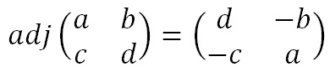

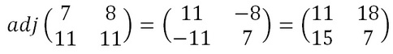

Multiply the Multiplicative Inverse of the Determinant by the Adjugate Matrix

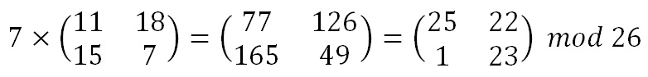

that is,
